Project Design Phase
Problem – Solution Fit Template

Date
Team ID | Team ID: __________
Project Name | AI Weather Wise
Maximum Marks | 2 Marks

Problem – Solution Fit Template:
AI Weather Wise addresses the problem of uncertain and difficult-to-understand weather information. The solution uses artificial intelligence and weather data to provide localized forecasts, simple weather insights, and timely alerts so users can make safer and betterinformed daily decisions.
Purpose:
❑ Provide simple, localized weather information for students, farmers, travelers, commuters and local communities.
❑ Use AI-based analysis to turn weather data into understandable forecasts, risk indicators and useful recommendations.
❑ Deliver timely alerts for rain, storms, extreme heat and other changing weather conditions.
❑ Help users plan travel, outdoor activities, agriculture and daily work by reducing uncertainty about upcoming weather.
❑ Understand the needs of different users and improve the weather experience through personalized and accessible information.

Template:
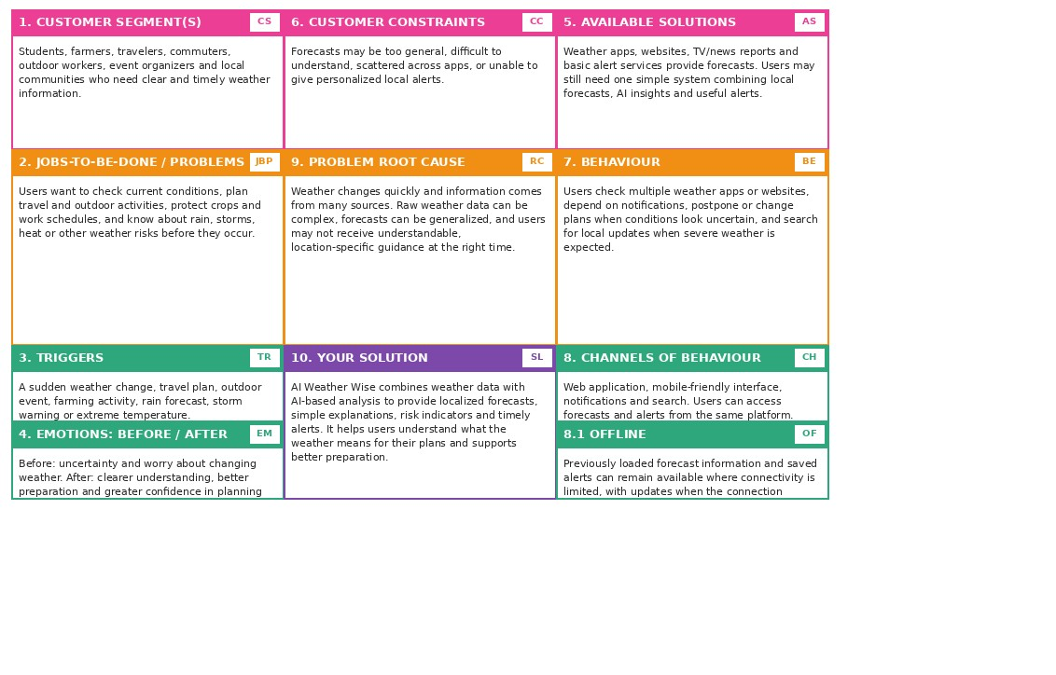
References:
- https://www.ideahackers.network/problem-solution-fit-canvas/
- https://medium.com/@epicantus/problem-solution-fit-canvas-aa3dd59cb4fe

